Lecture of Dispensing
Dr. Ahmed Mohsen Hamdan
Definition of Dispensing: The preparation, packaging, labeling, record keeping and transfer of a prescription drug to a patient or an intermediary, who is responsible for administration of the drug.
Advantages of Automatic dispenser: compact, fast, no interruption and minimize errors.
Parts of the prescription:
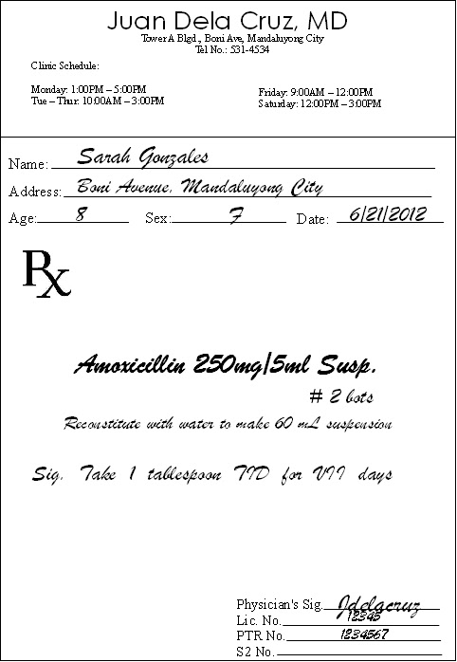
- The superscription: Prescriber name, Prescriber address, Patient name, Patient age, Diagnosis and Ŗx.
- The inscription: Brand name, strength and the amount.
- The subscription: The direction to the pharmacist (usually short sentences).
- The prescription: The direction to the patient.
- The signature.

- Abbreviations used in the prescription:
aa | ad | a.c. | Ad Lib | b.i.d | gtt | p.o | p.c. | s | w/o
Of each | Up to | Before meals | As much as one desires | Twice daily | Drop | Per mouth | After meal | Without | With

Dispensing Errors:
- Dispensing incorrect medication, dosage strength, or dosage form
- Dosage miscalculations
- Failure to identify drug interactions or contraindications
- Mislabeling
- Social and cognitive factors

10 Steps to Maximize Dispensing Accuracy:
- Lock up or sequester drugs that could cause disastrous errors
- Develop and implement meticulous procedures for drug storage
- Reduce distractions, design a safe dispensing environment, and maintain optimum workflow
- Use reminders such as labels and computer notes to prevent mix-ups between look-alike and sound-alike drug names
- Keep the original prescription order, label, and medication container together throughout the dispensing process
- Compare the contents of the medication container with the information on the prescription
- Enter the drug’s identification code (e.g., national drug code [NDC] number) into the computer and on the prescription label
- Perform a final check on the prescription, the prescription label, and manufacturer’s container; when possible, use automation (e.g., bar coding)
- Perform a final check on the contents of prescription containers
- Provide patient counseling (up to 83% of errors can be discovered during patient counseling).

Arrangement of Drugs in the Pharmacy:
WHO suggests the following guidelines are for arranging drugs.
• Shelves should be made of steel or treated wood.
• Shelves should be strong and robust.
• Drugs are arranged in alphabetical order of generic names.
• Each dosage form of drug is arranged in separate and distinct areas.
• Sufficient empty space should demarcate one drug or dosage form from another.
• Most recently received drugs are placed behind old stock on the shelf except where new drugs have shorter expiration dates.
• It is important to ensure the following rules in the dispensary and the store attached to the dispensary:
• Keep the environment clean.
• Always put lids properly on tins always and at the close of the day.
• Put drugs in a dry place protected from light and heat.
• Store liquids on a pallet on the floor or on the lowest shelf.
• The store must be cleaned daily and mopped at least once a week.

British National Formulary
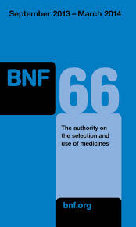
- The first non-numbered pages describe the changes in the BNF than previous one.
- The second 30 pages describe the Guidance for prescription.
- The third 60 pages describe the Emergency treatment of poisoning.
- The next 15 chapters are drugs classified into particular systems such as cardiovascular system in ch.2.
- The next 5 parts are indices and appendices.

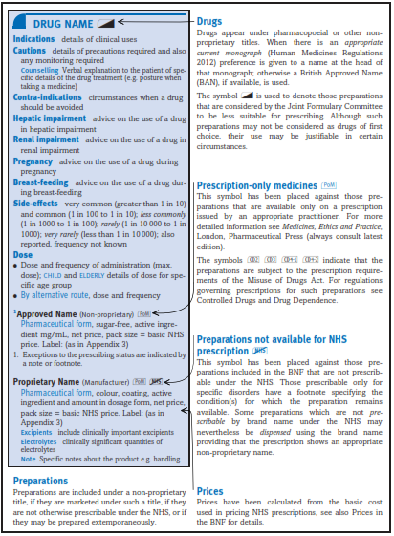
Good Dispensing Practice
A) Proper Labeling:
The label should contain the full description of the Patient's name, Patient's case, Patient's contact details, Doctor's name, Doctor's address, Doctor's contact details, Pharmacy's name, Pharmacy's contact details, Prescription Date, Drug, Strength, Dosage form, Full direction of usage and Dispensing Date
B) Proper Storage:
Use proper size container, proper sealing from light, moisture and heat.
Ex: Light sensitive drugs: Acyclovir, Atenolol, Beperidil and Claforan.
Ex: Heat sensitive Drugs: Thorazine, Cognitin and Desipramine.
Ex: Oxygen sensitive drugs: Amiodarone, Bleomycin and Cordaron.
Ex: Hydrolysable drugs: Acetaminophen, Amiodarone, Chlorpromazine and Clonidine.

C) Proper Dispensing Environment:
Dispensing environments must be clean, because most medicinal products are for internal use, making it important that they be hygienic and uncontaminated. The environment must also be organized so that dispensing can be performed accurately and efficiently. The dispensing environment includes:
• Staff
• Physical surroundings
• Shelving and storage areas
• Surfaces used during work
• Equipment and packaging materials

D) Good Dispensing Process:
- Label it properly and check for expiry data.
- Clean and organize the working area.
- Proper recording of the drugs (inventory control)

E) Good Dispenser:
The dispenser must be: Organized, Knowledgeable, Trained, Honest and Communicative.

Procedure for ordering drugs from stores:
1- There are two types of ordering sheets: Blanket Purchase Order or One-time Purchase order.
2- There are three types of drug agency: The manufacturing company, the distributing company and the subagent sources.
3- Be sure that the same medication, dosage form and strength as ordered drugs.
4- Be sure that the medication is well transported and has no physical changes.
5- Be sure that the medication has no expiration date problem.
6- Pay the money according to the invoice.
7- Register the medication in the pharmacy according to the Barcode using the electronic system for recording drug dispensing.
Key points:
Definition of Dispensing, Parts of the prescription, Abbreviations, Dispensing Errors, Steps for Maximizing Dispensing accuracy, Arrangement of the Drug in the pharmacy, British National formulary and Good Dispensing practice.
References
- Pharmaceutical dispensing; a text-book for students of pharmaceutical compounding and dispensing and a reference book for pharmacists, by William J. Husa, 21th ed, 2013
- FASTtrack: Pharmaceutical Compounding and Dispensing, by Langley, Christopher A; Belcher, Dawn, 2nd ed, 2012
- Pharmaceutical Compounding and Dispensing, by Christopher A. Langley, Dawn Belcher, 1st ed, Pharmaceutical Press, 2012.
- Pharmaceutical Compounding and Dispensing, by Marriott, John; Wilson, Keith; Langley, Christopher A; Belcher, Dawn 2nd ed, 2010

